**K-ARMED BANDIT**

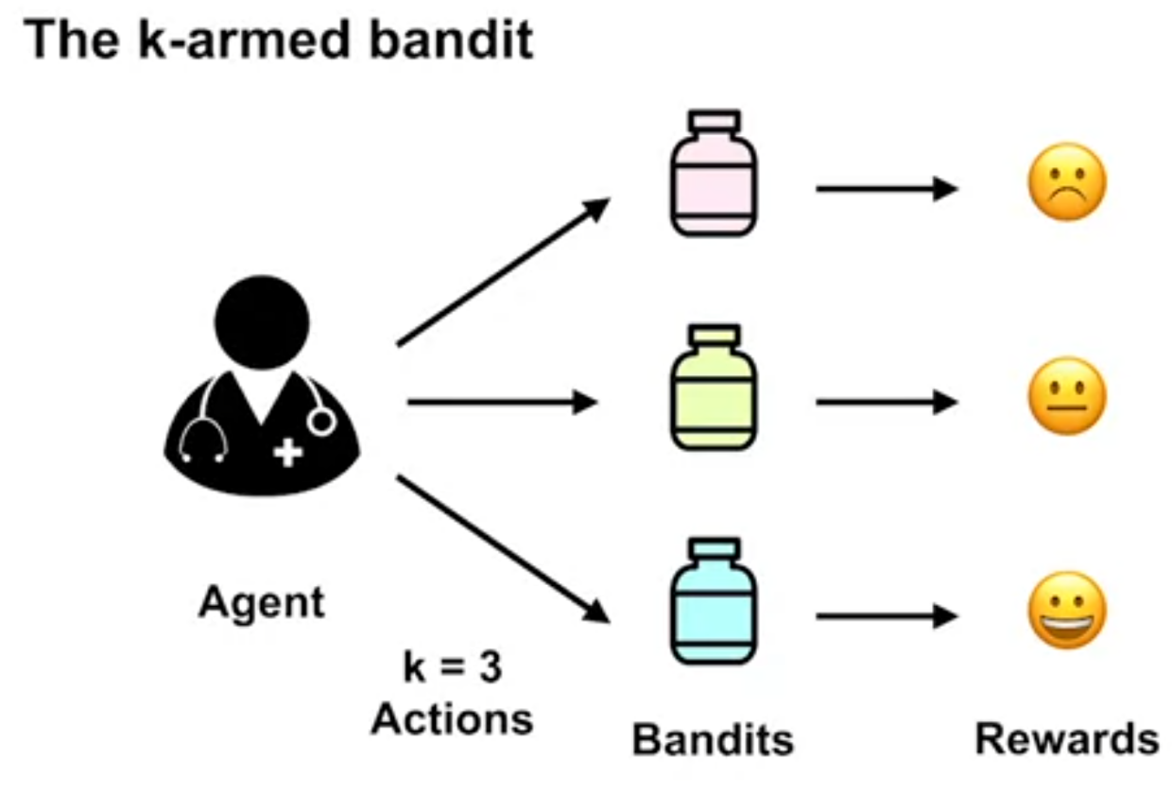

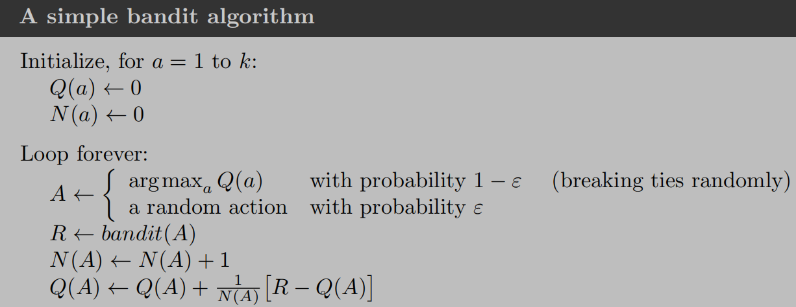

1/N(A) called the step size

* Action values:

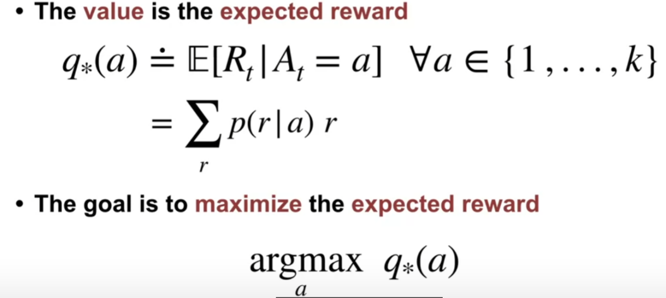

q star of a is defined as the expectation of reward received(R_t), given we selected action a, for each possible action one through k. Inside the sum, we have multiplied the possible reward by the probability of observing that reward.

* Some methods of balancing exploiting vs exploration:

1. **Epsilon-greedy**: epsilon refers to the probability of choosing to explore

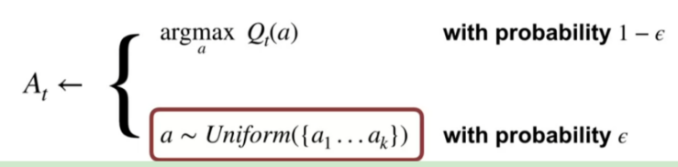

1. **Optimistic initial values:** optimistically initial Estimate value at the beginning, then the estimation value will decrease over the time.

Cons: only drive exploration early in the learning, thus it is not suitable for non-stationary problem (An optimistic agent may have already settled on a particular action, and will not notice that a different action is better now)

1. **UCB (upper-confidence bound action selection):** instead of uniformly choosing an exploration action a(like epsilon-greedy), choose the action with higher upper bound of confident interval of Q*(a)- expectation of reward received

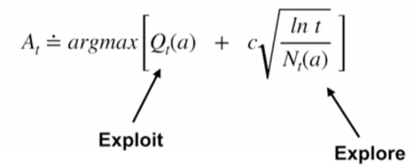

* Non-stationary vs stationary multi-armed bandit problem: the reward distribution do not change over time

Ex: after 1000 steps we will randomly change the expected value of all of the arms

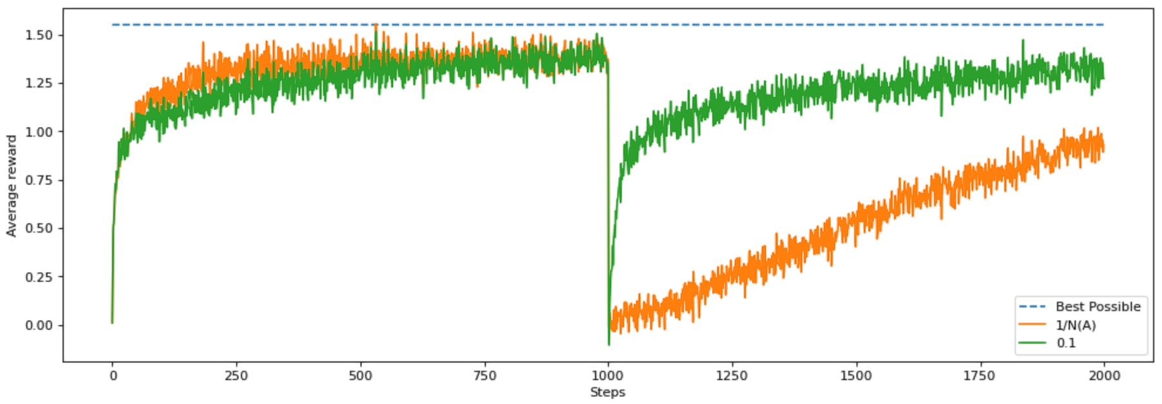

if the best action gets chosen 500 times. That means the step size for that action is 1/500 or 0.002. At each step when we update the value of the action and the value is going to move only 0.002 * the error. That is a very tiny adjustment and it will take a long time for it to get to the true value.

The agent with step size 0.1, however, will always update in 1/10th of the direction of the error. This means that on average it will take ten steps for it to update its value to the sample mean.

* Issue: k-armed bandit doesn’t count different situation call for different actions and long term result

**FNITE MARKOV DECISION PROCESS** (Sequential decision making problem)

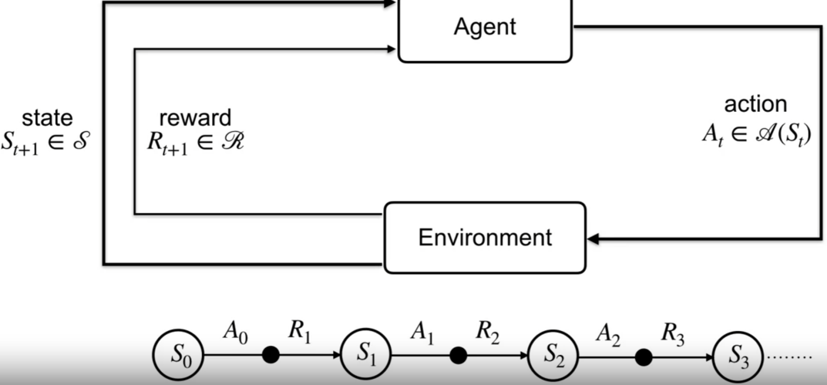

Restriction: The state must include information about all aspects of the past agent–environment interaction that make a difference for the future

State: environment variables that changes based on previous actions

At each time, the agent receives a state S_{t} from the environment from a set of possible states, script S. the agent selects an action A_{t} from a set of possible actions. Script A of S_{t} is the set of valid actions in state S_{t}.

* 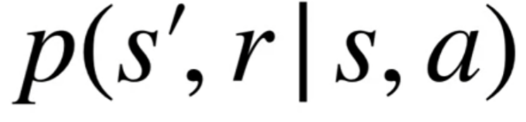

Given a current state S and action a, p tells us the joint probability of next future state S prime and reward r.

* Markov property: present state is sufficient and remembering earlier states would not improve predictions about the future
* Case study

1. 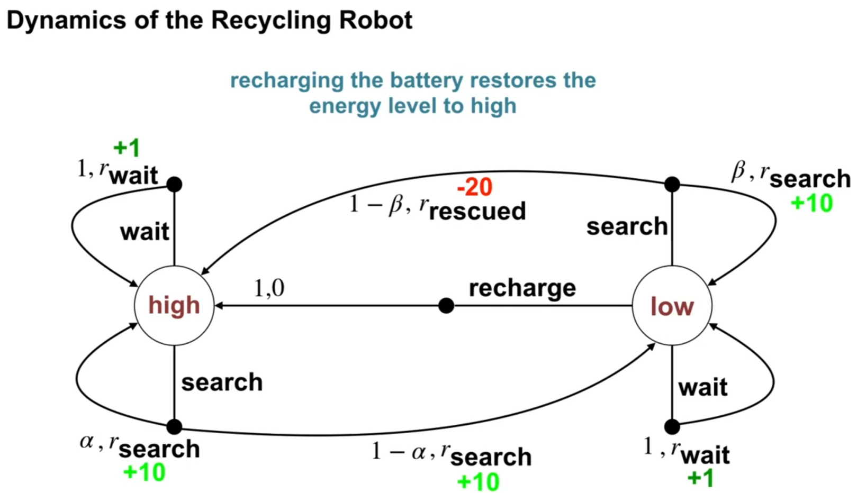

* Episodic tasks: agent environment interaction breaks up into episodes

e.g: each game of chess is an episode

* Continuing task

E.g: smart thermometer, needs to continuing interactive with environment

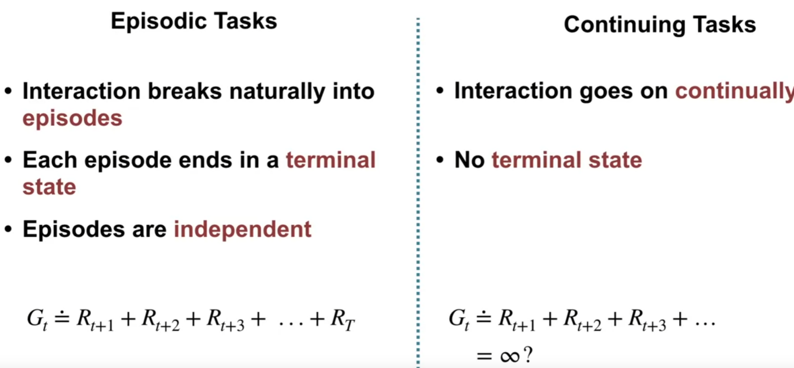

G_{t} is the return at time step t

Problem: how to make sure G_{t} is finite? Using discount rate gamma

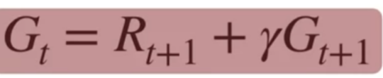

Immediate reward contribute more to the sum, the more to the future the less it contributes

1. Gamma -> 0: the agent only care about immediate reward and it’s short sighted
2. Gamma ->1: agent takes future reward more strongly

* Policy π: a mapping from states to probability of selecting each possible action. Π(a|s)

State value function vpi(s): expected return when starting in s and following pi thereafter. vpi(s) is the state value function fro policy pi

Action values function for policy pi qpi(s,a): expected return starting from s, taking action a and thereafter following policy pi

* Optimal state value function: one policy that results better than or equally state value to all other policies. The state value function under that policy is called optimal state value function

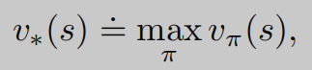

* Policy: 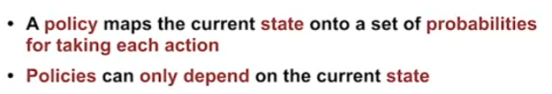
* Value functions

1. **State-value function**: expected return from a given state under a specific policy

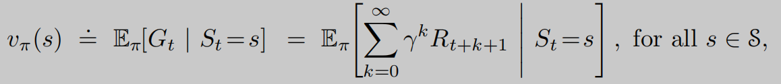

Immediate reward+ discounted future rewards

1. **Action-value function**: expected return from a given state after taking a specific action, later following a specific policy

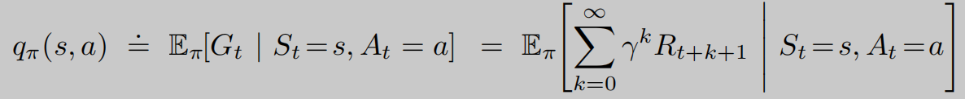

* Bellman equation

1. **State-value:**

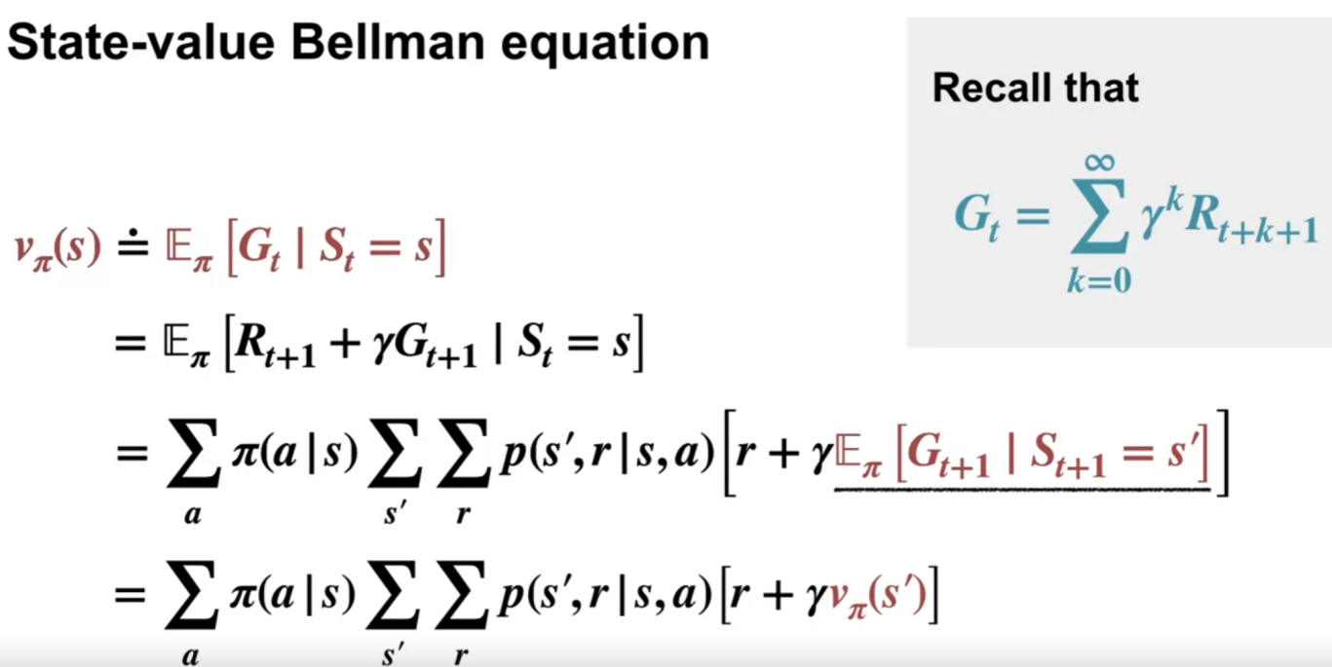

the return at time t, can be written recursively as the immediate reward plus the discounted return at time t plus 1

P(s’,r| s,a) is 1 if the state only leads to one result

**Note**: pi_(a|s) can be collected using deep q-learning, softmax the output of four predicted action gives the prob of taking each action

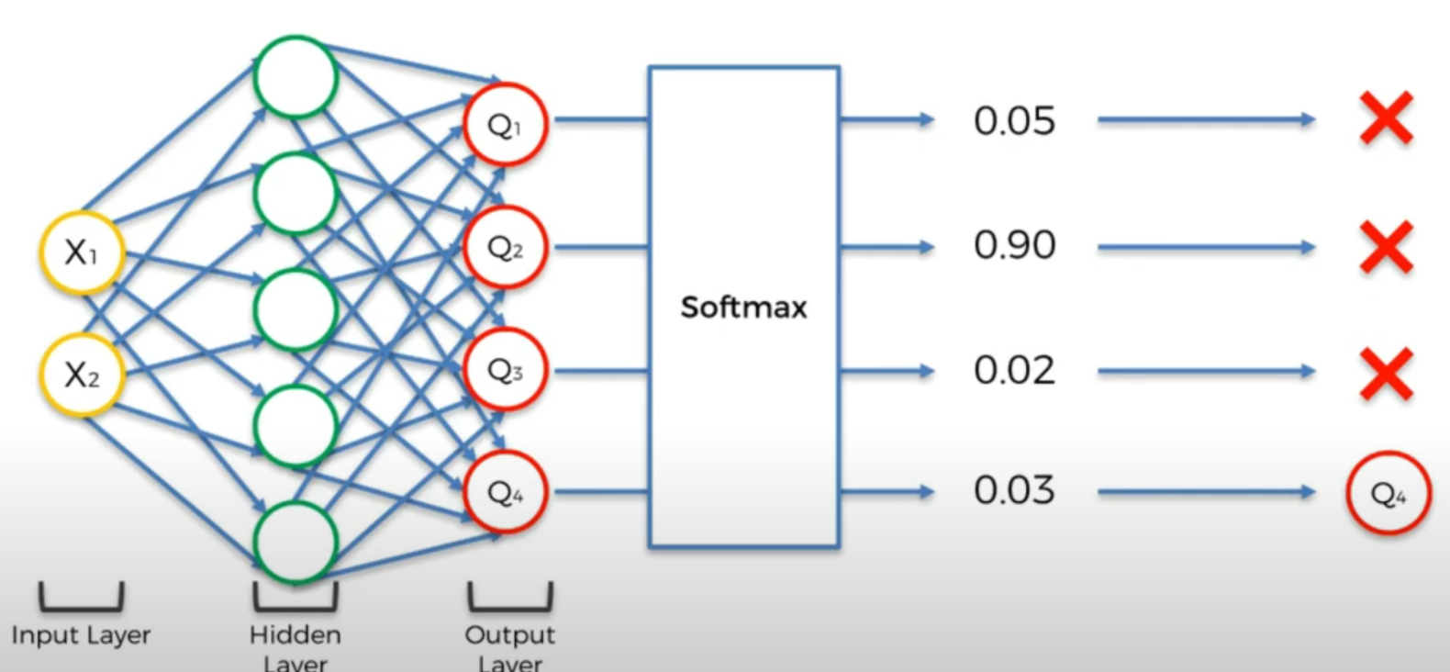

1. **Action-value:**

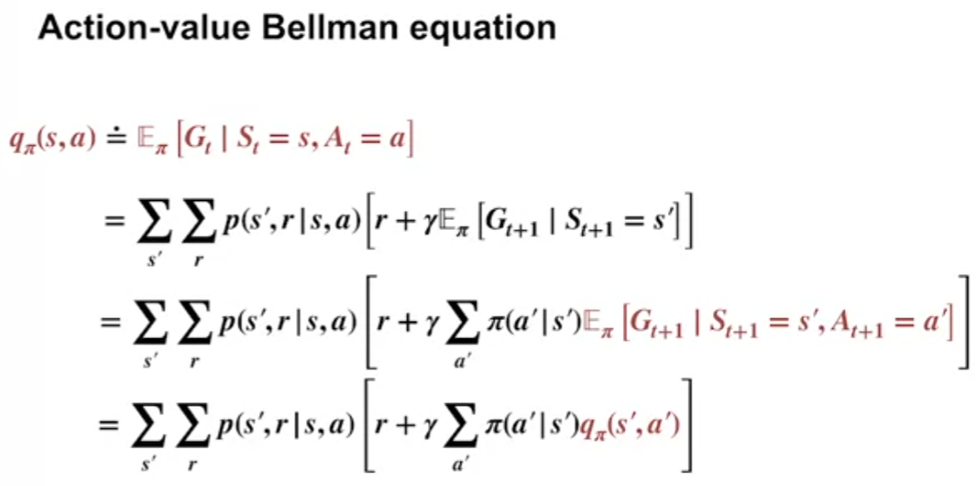

**ie.: state-value of gridworld**

Start at A, the prob of landing on B is 1/4, p(s’,r | s,a) is 1 in this case; reward r is 5, gamma is 0.7, next state-value function v` is V_pi(B). Because for each action there's only one possible associated next state and reward. That's the sum over s prime and r reduces to a single value. Sum up all possible policies (B,C,A when we move up or left, it will return to A)

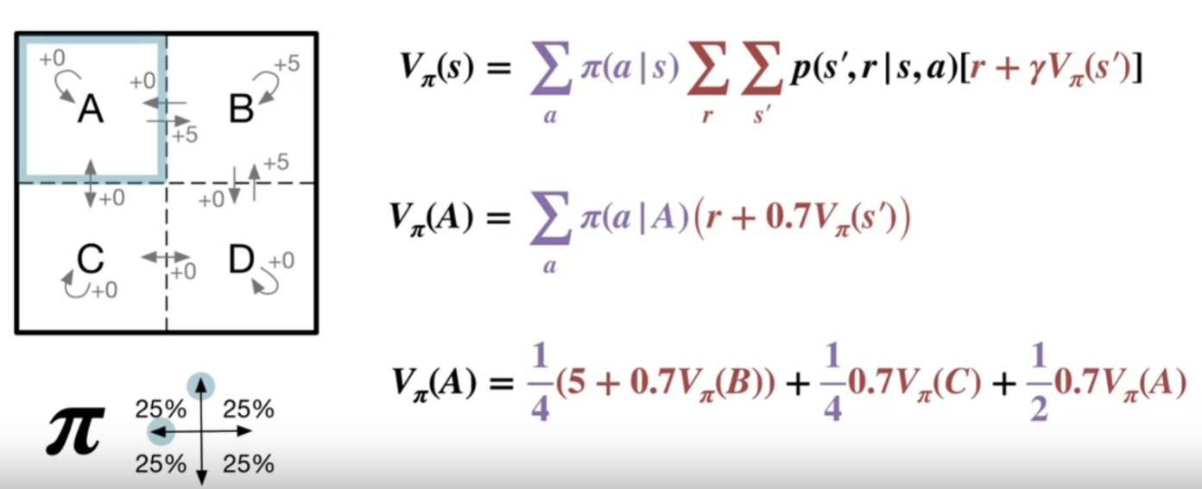

Derived other three with the same method and solve for 4 state-values with four equations

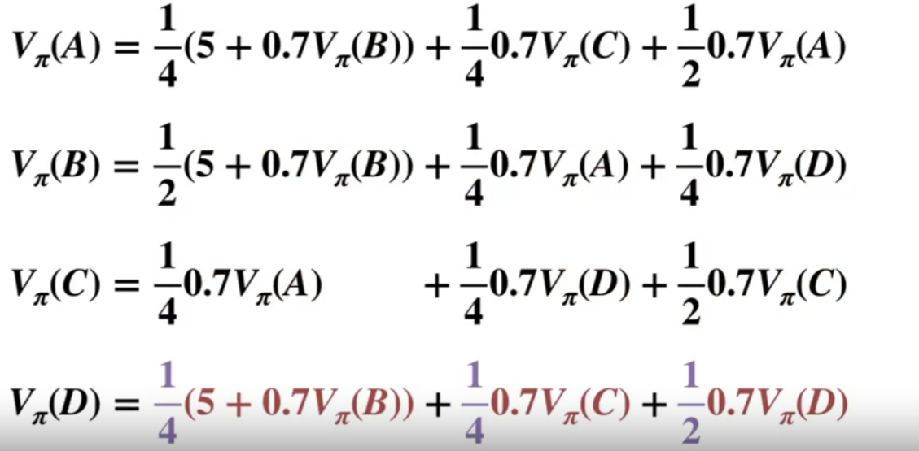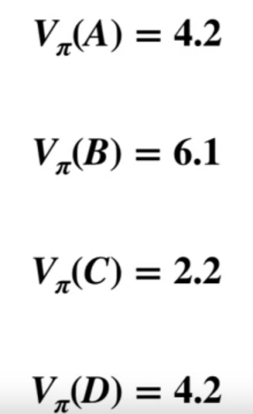

**NOTE:** agent can’t go backward, it only goes up, left, right, not down

Thus, i.e. p(up) = 80%, p(left) = p(right) = 10%

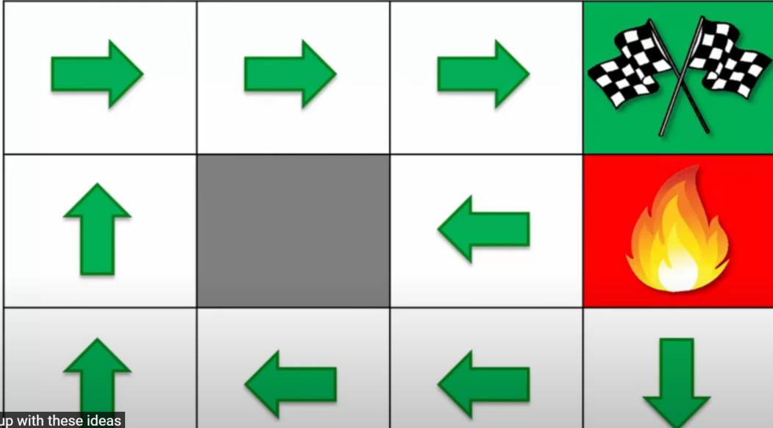

* Bellman optimality equation

1. **Optimal State-value:**

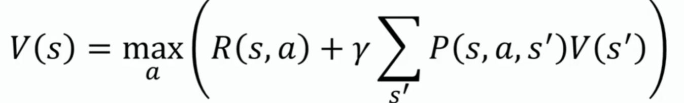

**value of the state is the max value of all possible actions**

1. **Optimal action-value**

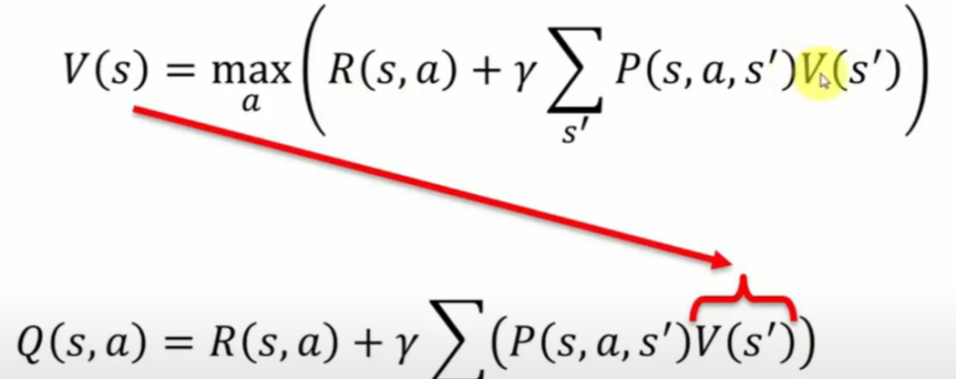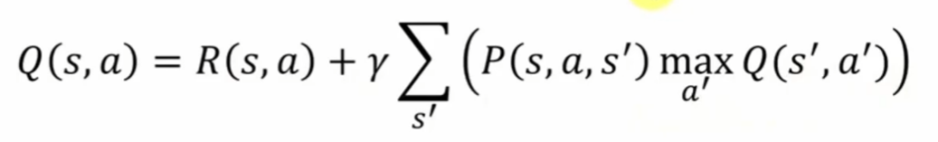

Optimal value can’t be solved

If we know either one of them, we can find optimal policy

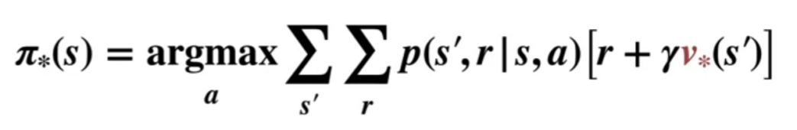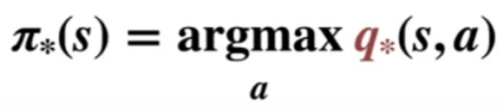

* The effects on reward

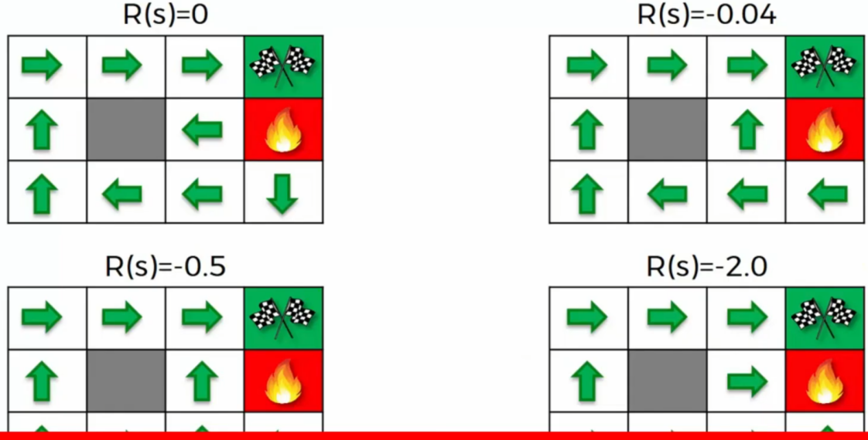

* Policy revaluation: Computation of the value function for a give policy

Policy improvement: computation of an improved policy given the value function for that policy. It is a strict improvement unless the original policy was already optimal

Put together: we have policy iteration and value iteration

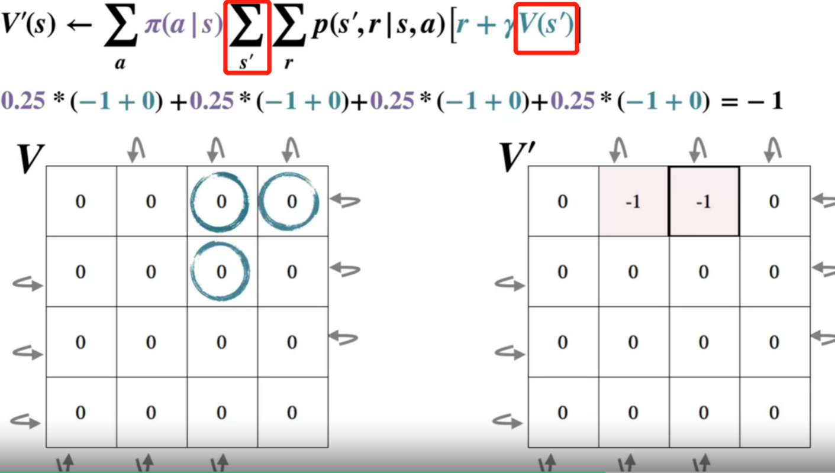

-1.7 = 0.25*(-1+0)+ 0.25*(-1-1)+0.25*(-1-1)+0.25*(-1-1)

Note: state is one iteration, V(s`) is the state value function corresponding to its own action (each individual box)

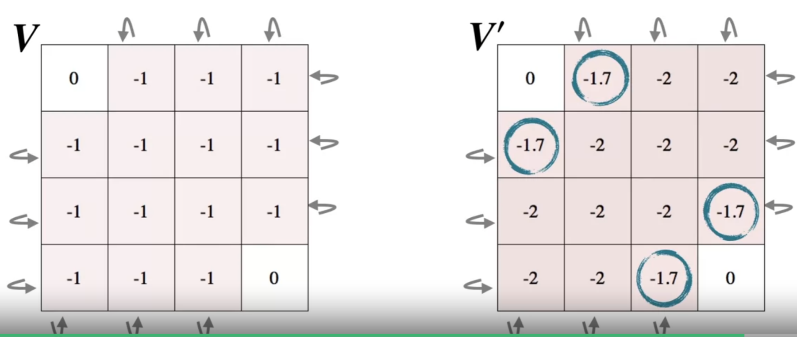

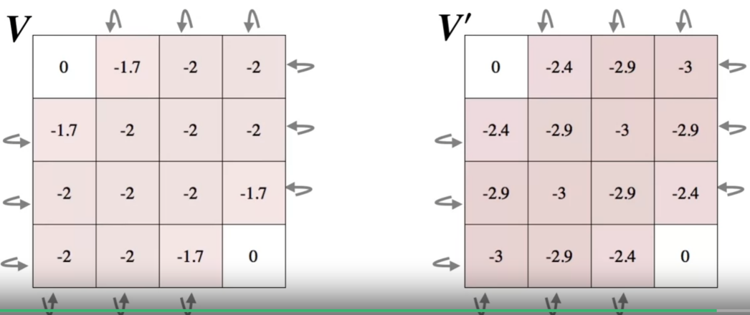

... eventually when the difference between previous and current is smaller than 0.001, we stop

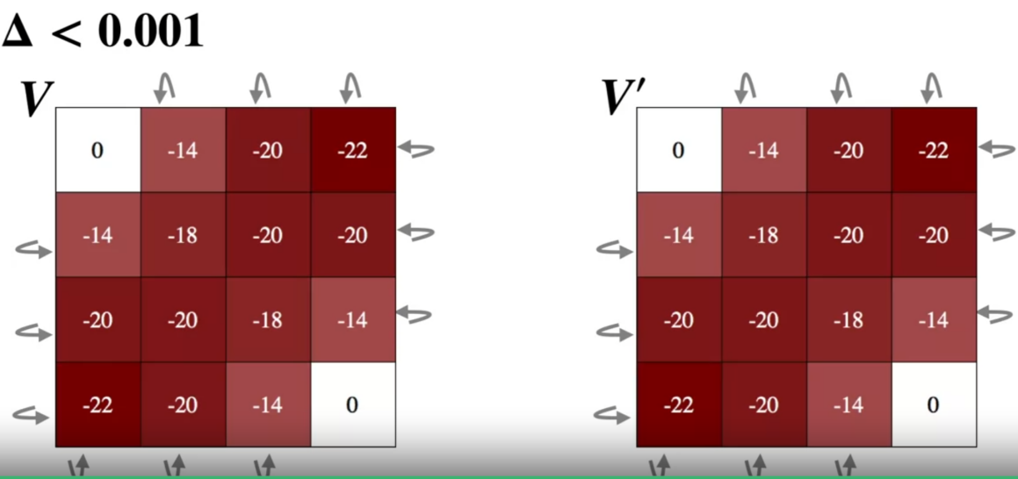

* Policy iteration vs value iteration

1. **Policy iteration:** find the action that result the best action value, only take that action by altering pi(a | s)=1

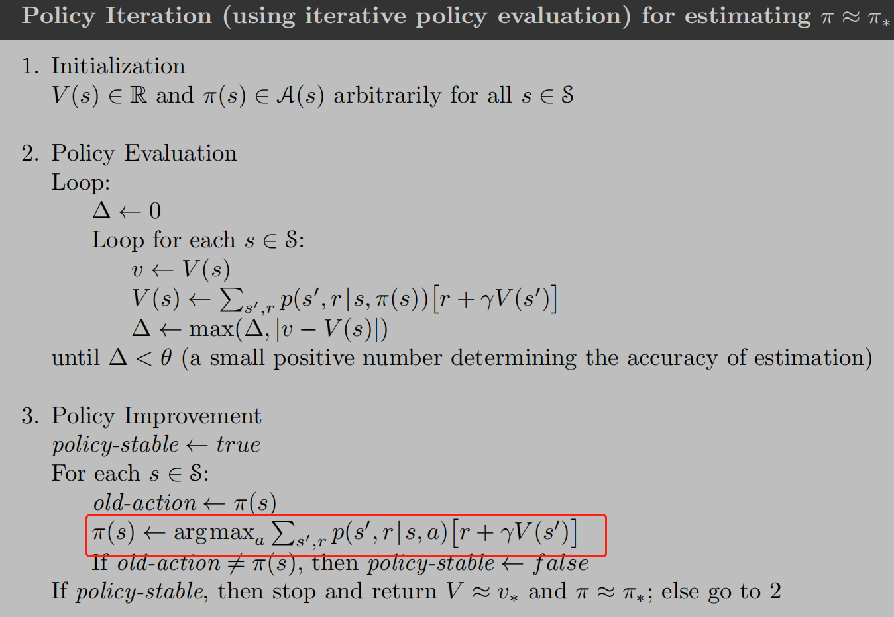

1. **Value iteration:** assign greatest value to each state’s value function first to speed up the initial policy evaluation

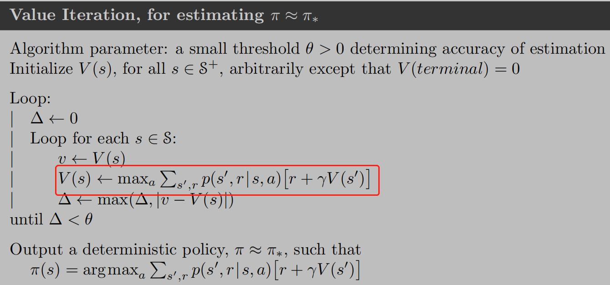

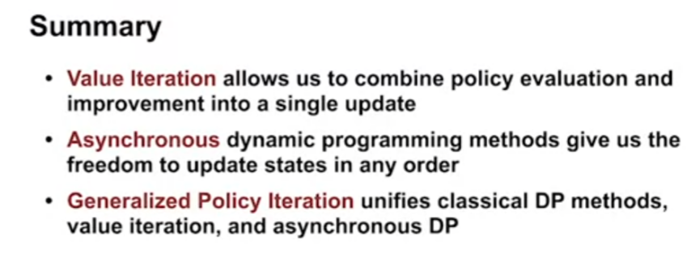

**MONTE CARLO METHOD (only for episodic MDP)**

* **Monte carlo method vs Dynamic programming:**

1. Mcm: estimate the value of an individual state independently of the value of any other states, don’t do sweeps over action space
2. Dp: value of each state depends on the values of other states

* Note: Monte Carlo methods cannot be used in the case that won’t reach the termination. If a policy was ever found that caused the agent to stay in the same state, then the next episode would never end

(vs Sarsa can be used even without reaching the terminal, because they quickly learn during the episode that such policies are poor, and switch to something else)

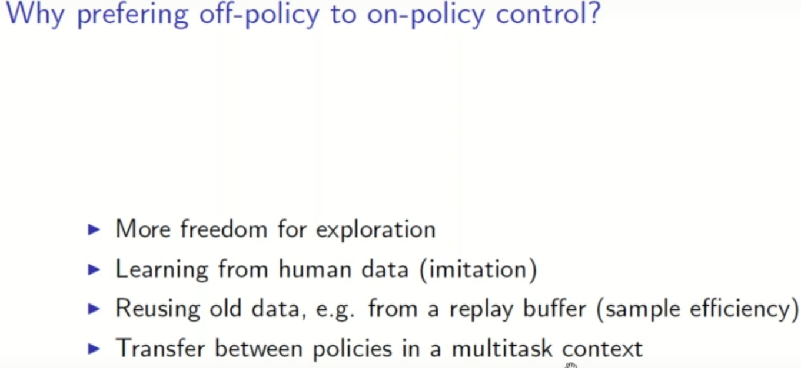

* Refresh: Q-learning

1. Q-learning is a **model-free** reinforcement learning algorithm.
2. Q-learning is a**values-based** learning algorithm. Value based algorithms updates the value function based on an equation(particularly Bellman equation). Whereas the other type, policy-based estimates the value function with a greedy policy obtained from the last policy improvement.
3. Q-learning is an **off-policy** learner. Means it learns the value of the optimal policy independently of the agent’s actions. On the other hand, an **on-policy** learner learns the value of the policy being carried out by the agent, including the exploration steps and it will find a policy that is optimal, taking into account the exploration inherent in the policy.

<https://towardsdatascience.com/a-beginners-guide-to-q-learning-c3e2a30a653c>

* On-policy vs off-policy

1. On-policy:
2. Off-policy: agent learning the policy from data generated by following a different policy (target & behavior). Thus the the policy that we are learning is off the policy we are using for Action selection:

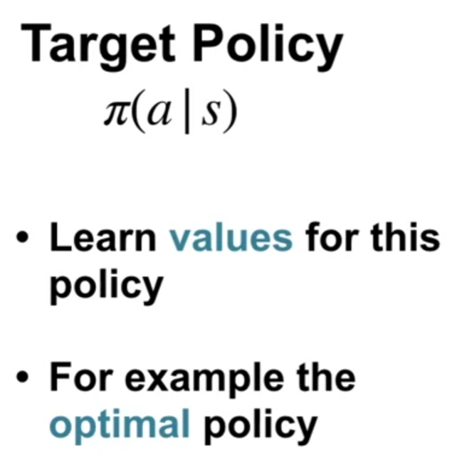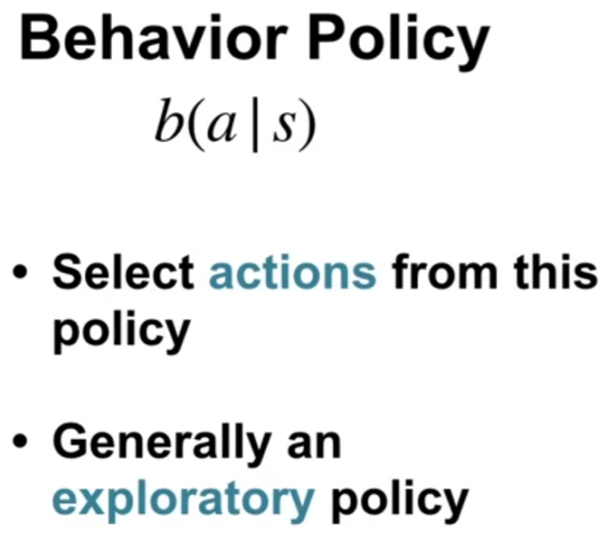

Off policy learning is a generalization of on policy learning. This will experience much large number of states. **Behavior policy must cover the target policy**

* Importance sampling: use samples from one probability distribution to estimate the expectation of a different distribution

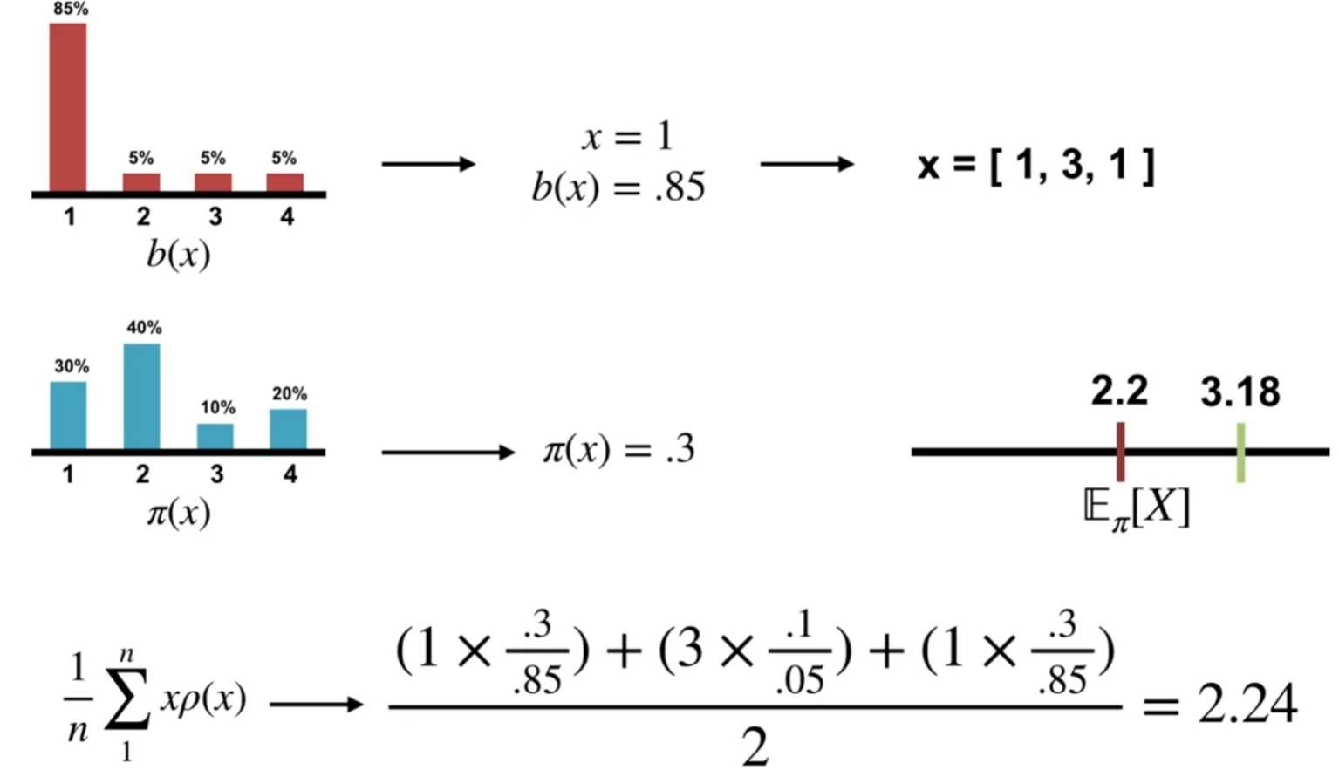

* Monte carlo Exploring starts requires first state and action are choose randomly at beginning of each episode, two ways of exploration techniques:

1. Epsilon-soft policies

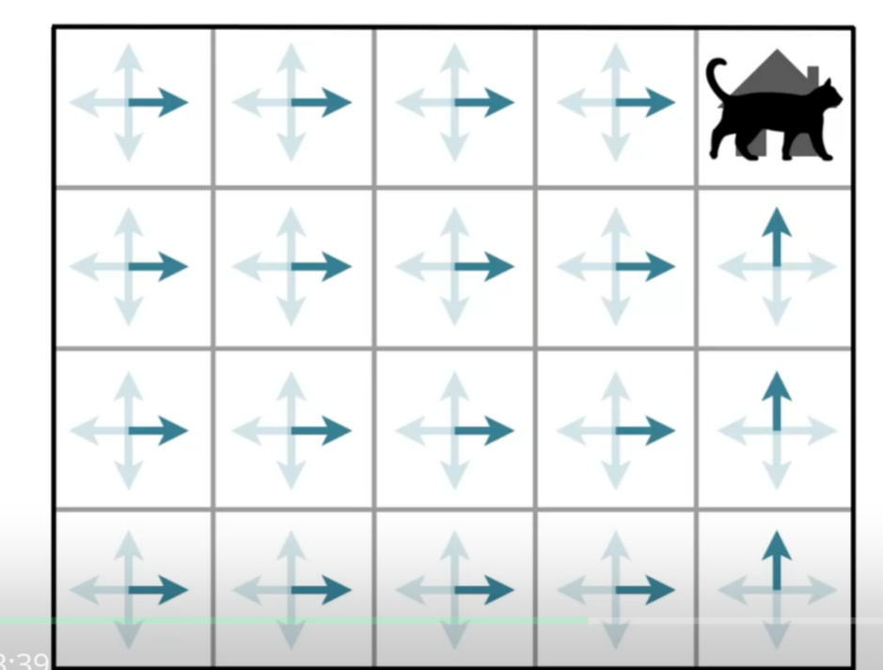

1. Off policy learning (to learning an optimal policy and still maintaining exploration):

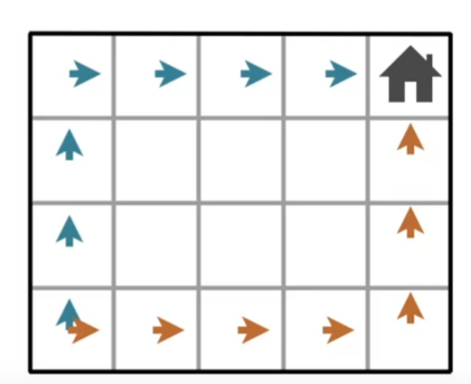

* 1. Behavior policy

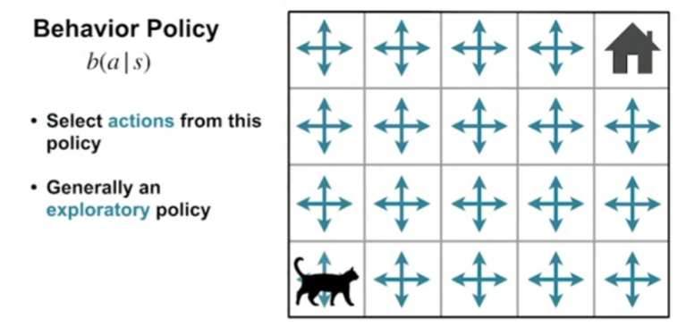

* 1. Target policy

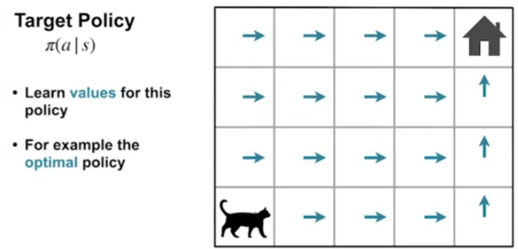

One way to learning about behavior policy while following the target policy is to use importance sampling

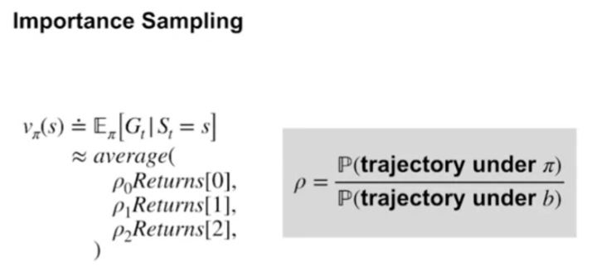

**Temporal Difference Learning** (combo of Monte Carlo and Dynamic programming)

* TD only needs the next state while DP needs expectation over all possible next states. Compare:

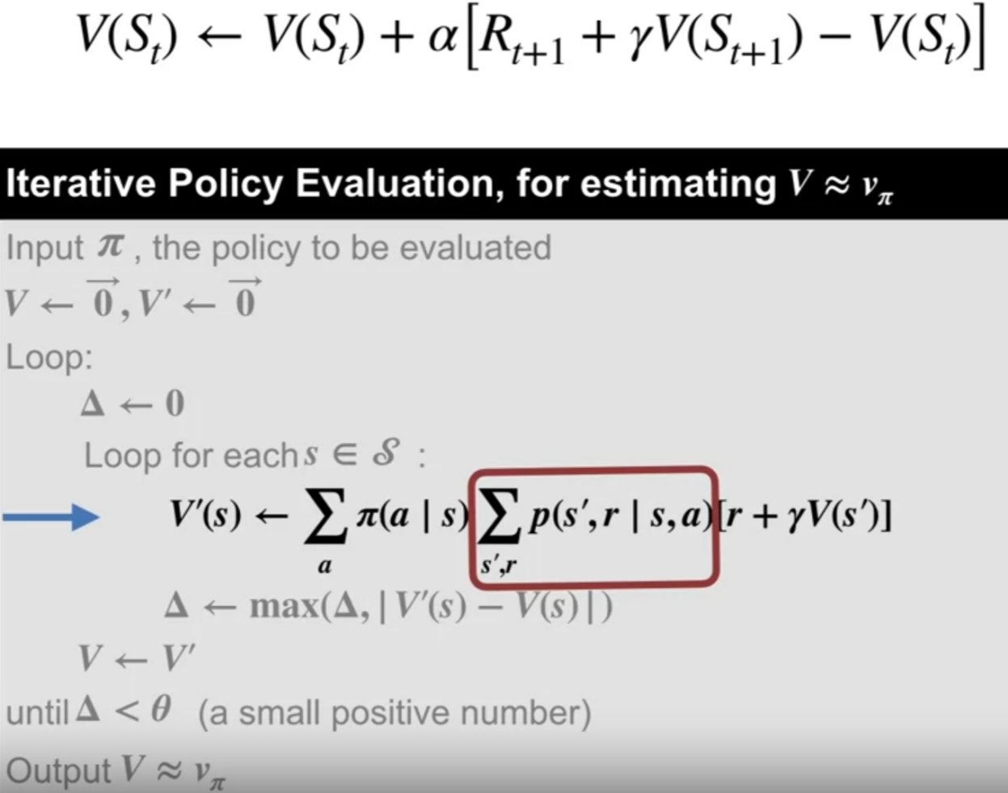

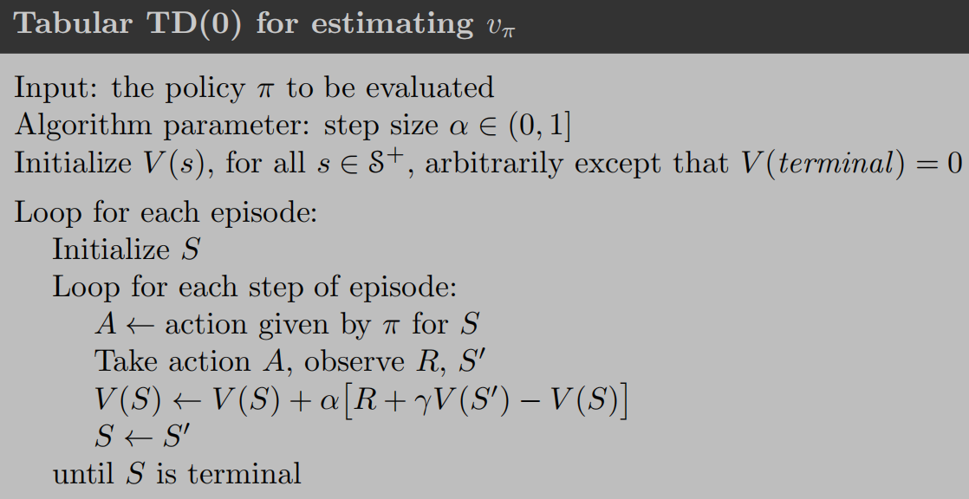

* Example:

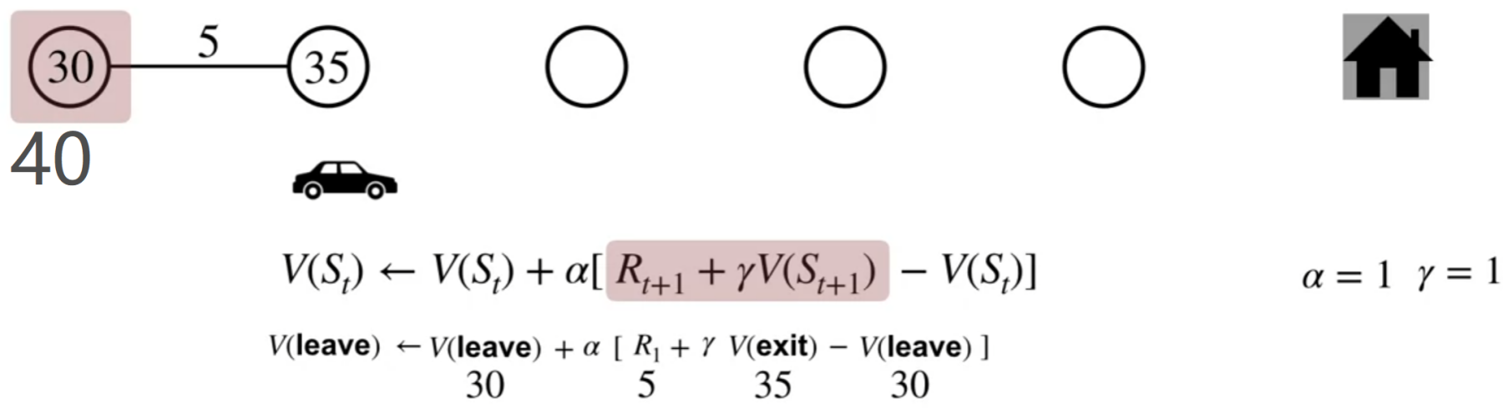

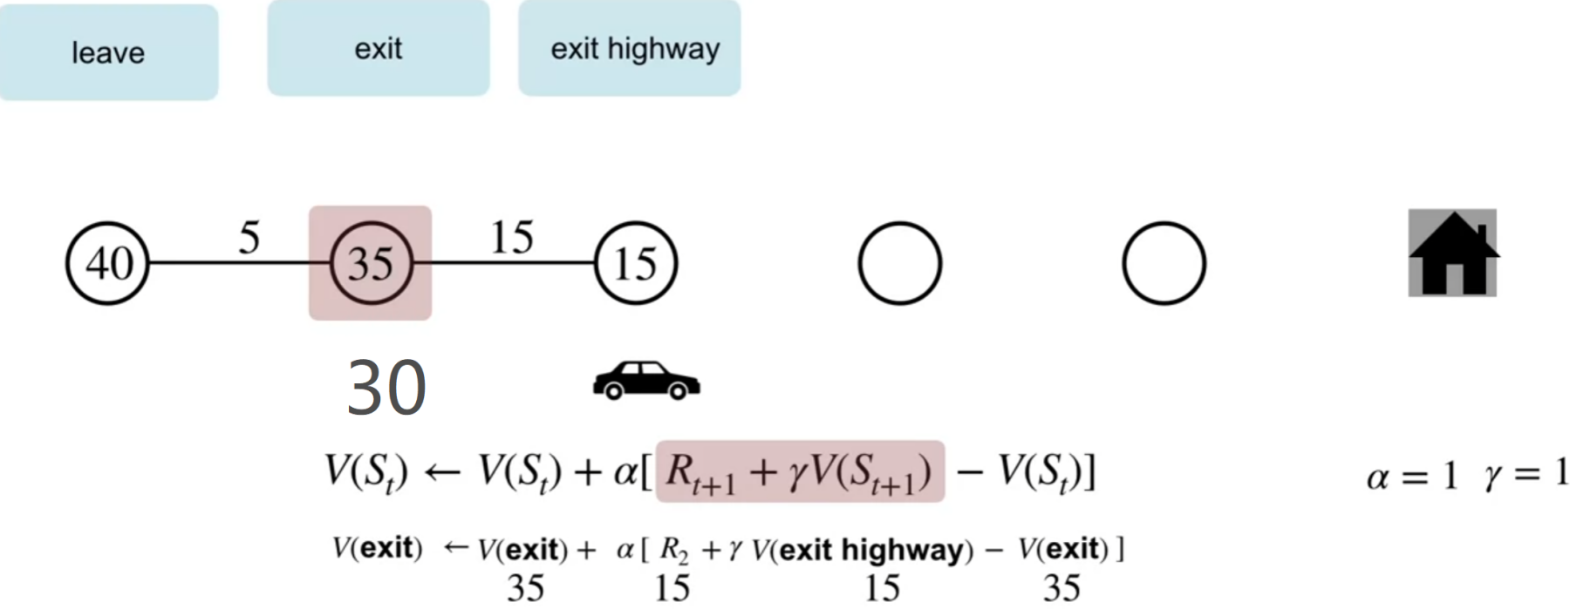

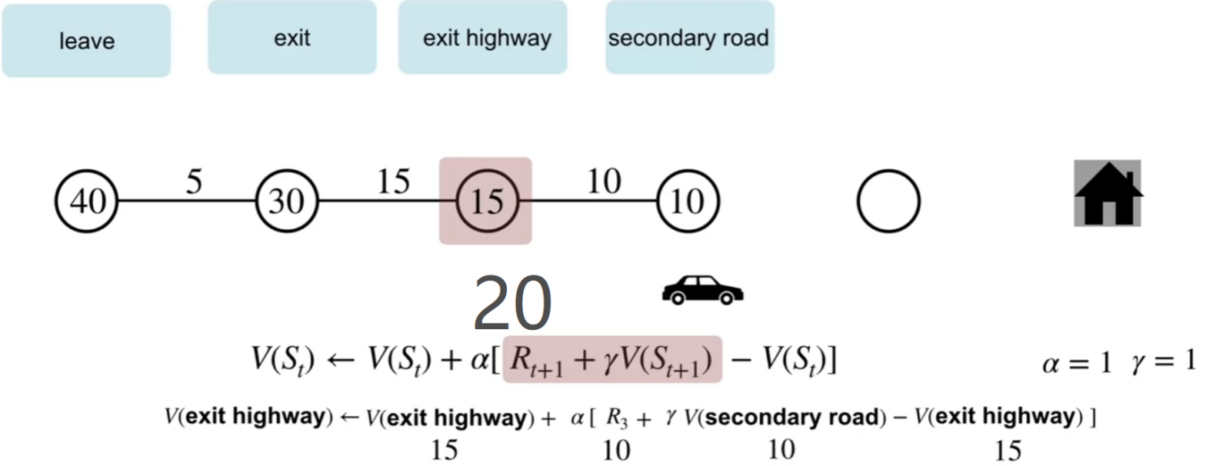

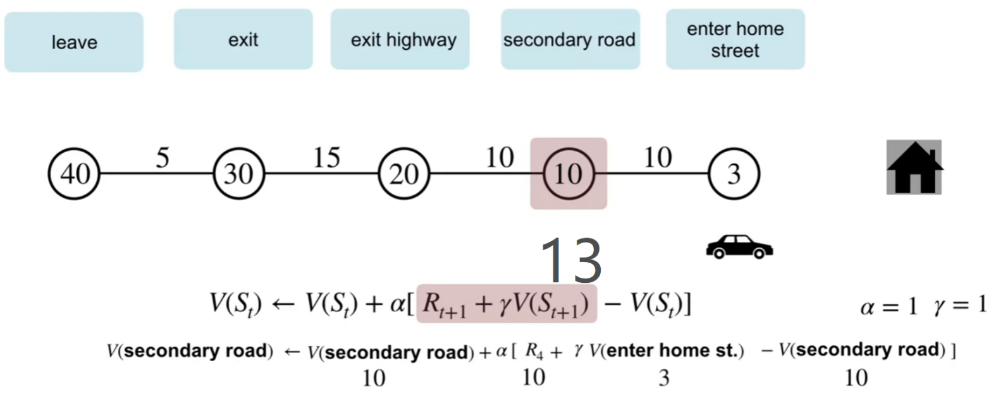

For terminal state:

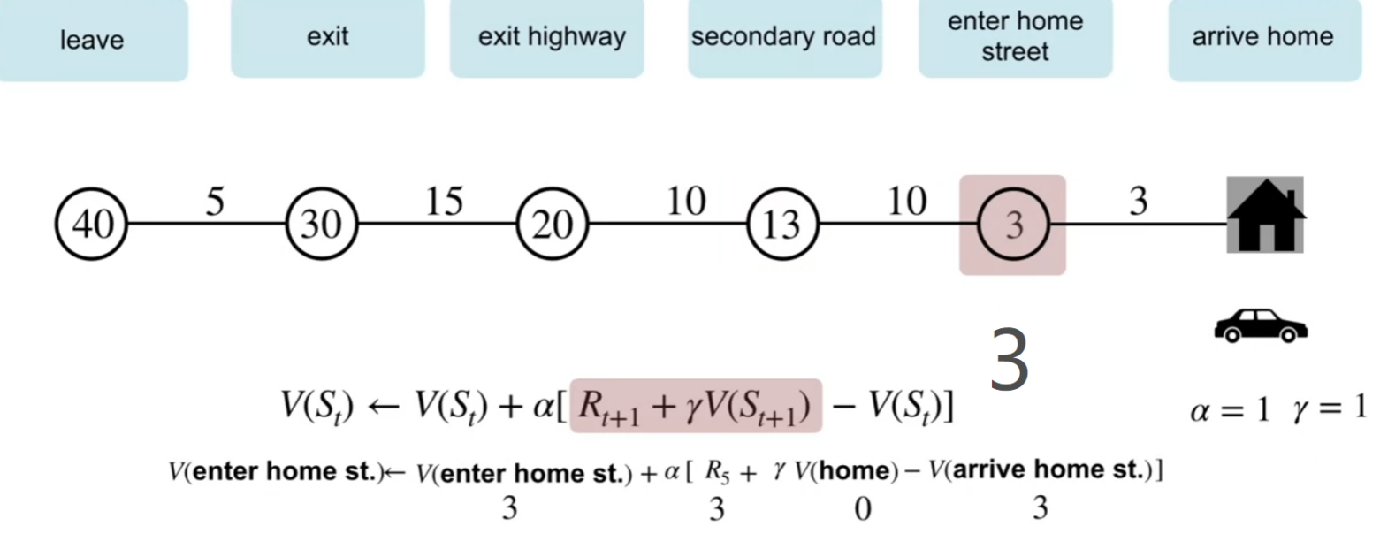

This way we can learn without waiting to know the final outcome unlike monte carlo

* Adv of TD

1. Online and incremental (vs monte carlo), means don’t need to wait until the end of episode, only need the next state
2. Doesn’t require a model of the environment(vs Dynamic programming)
3. Converge faster than MC methods

* Bootstrapping in RL: update a value based on some estimates and not on some exact values (DP, TD)
* MC targets generally have higher variance while TD(0) targets usually have lower variance.

**SARSA(**on policy TD control**) & Q-LEARNING (**off policy TD control**)**

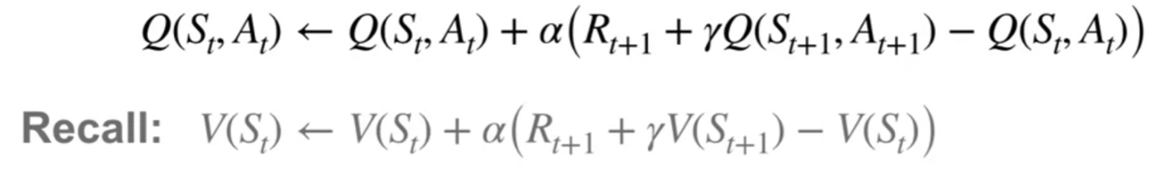

* The same as TD except using **state-action** pair, action value
* V(s) vs Q(s,a):

1. V_pi(s): is the avg of a state, [top, bottom, left, right] avg the return
2. Q_pi(s,a): is the avg of state&action pair

* Sarsa is more conservative than Q-learning, **expected Sarsa** performs better in the long run and more robust with large step size, **q-learning** is a special case of **expected Sarsa**

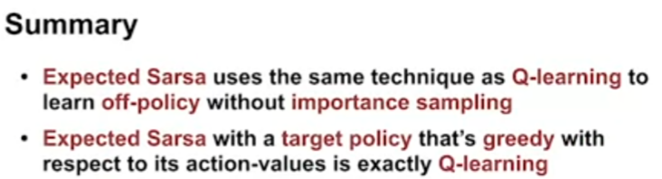

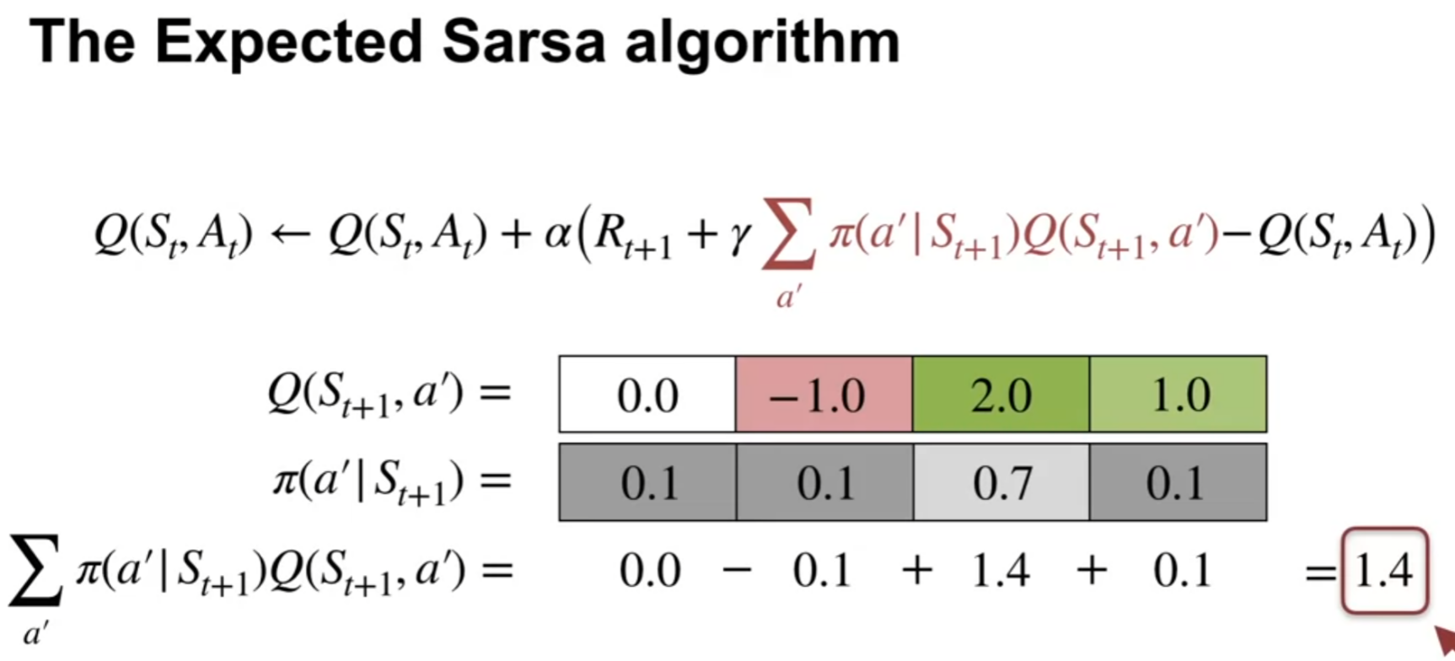

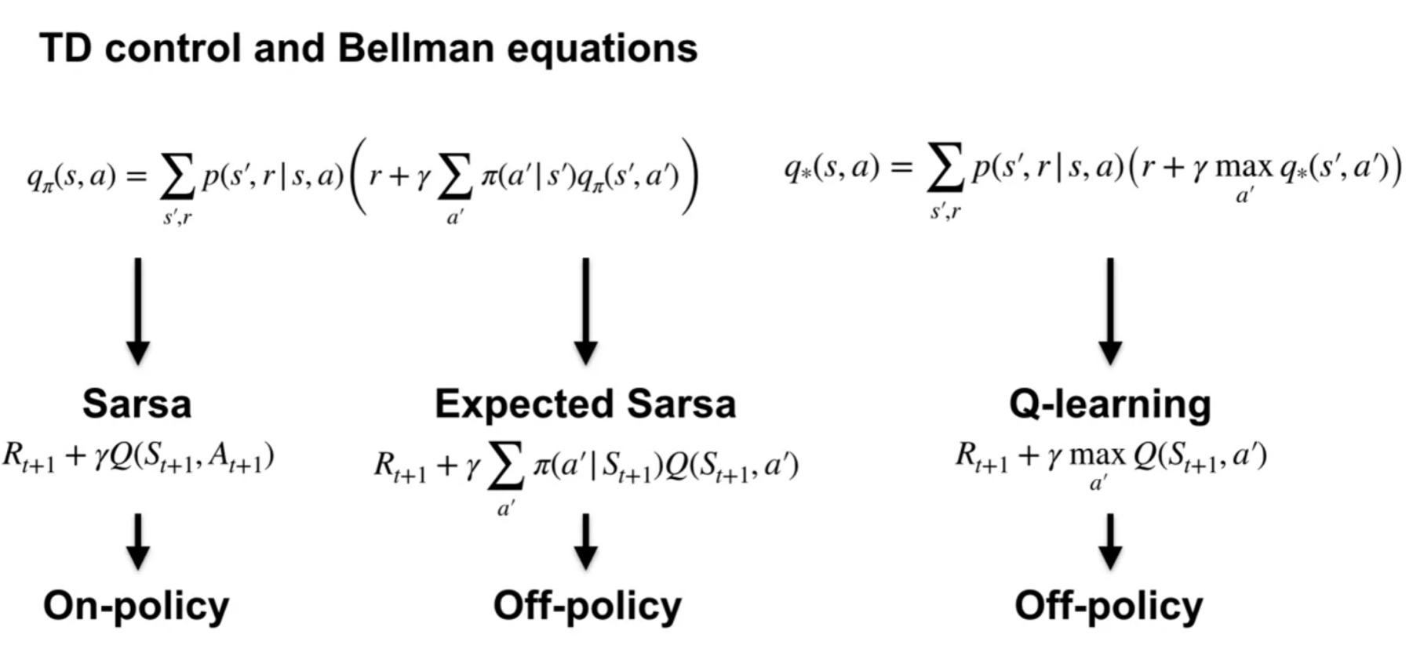to compute pi:

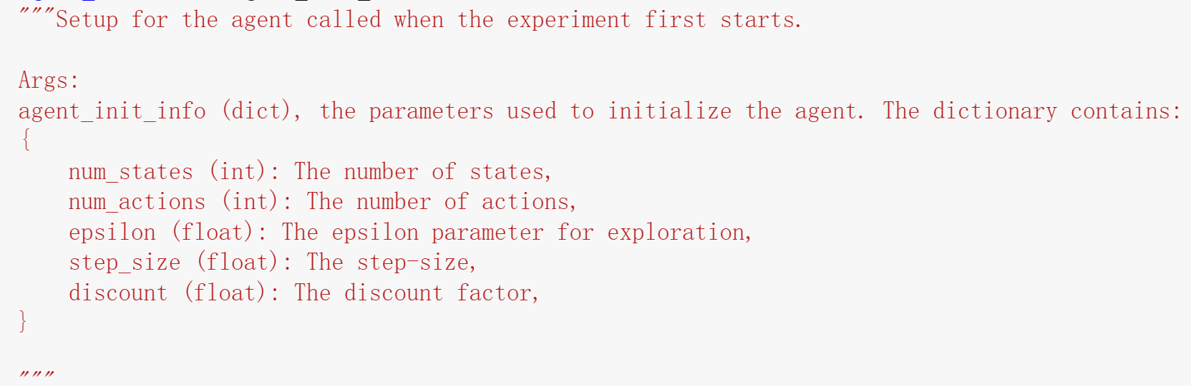

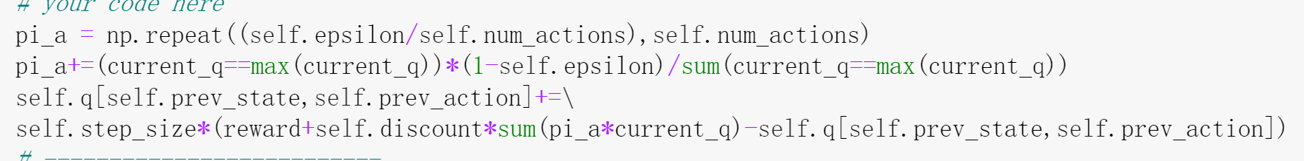

**DYNA-Q**

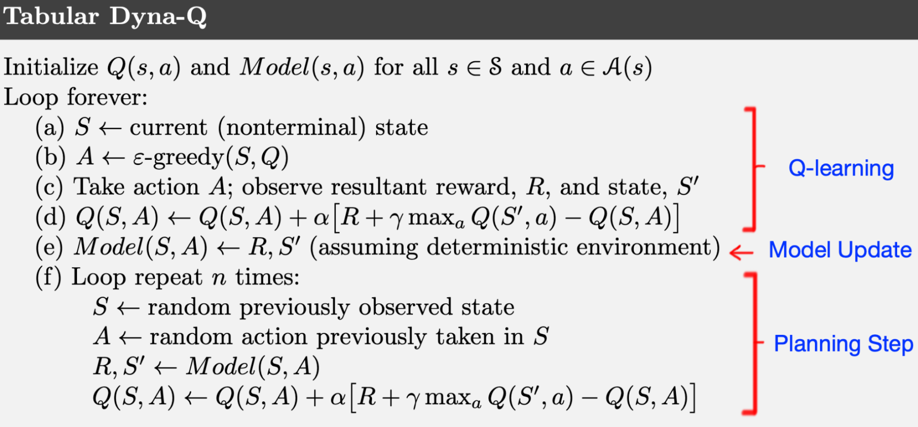

If n is 0, then it is Q learning. Model is a dictionary of dictionary that simply update the lookup of given a action and current state what’s the reward and next state

* When environment changes (aka model becomes inaccurate):

DynaQ+ update reward using

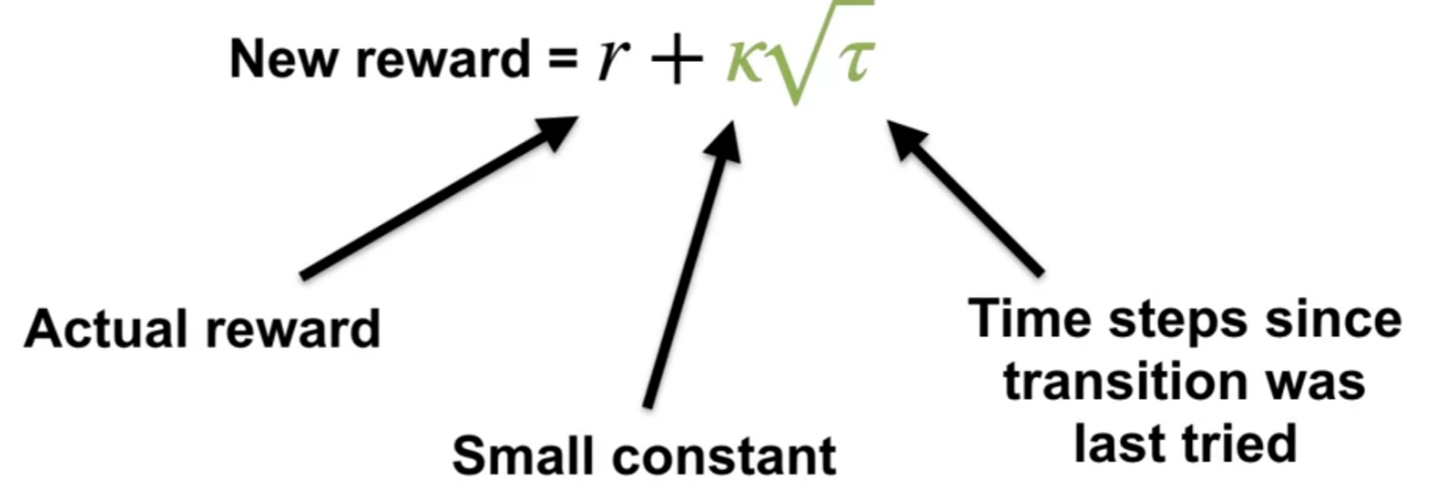

if the modeled reward for a transition is r, and the transition has not been tried in τ(s,a) time steps, then planning updates are done as if that transition produced a reward of r+k*√τ(s,a), for some small κ.

To encourage model to explore

**Review**:

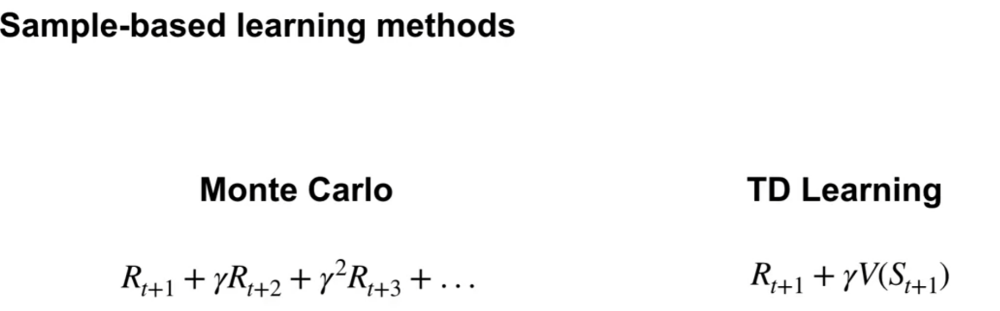

TD algorithm can estimate both state value and action value functions

Control using sarsa, exp sarsa, q-learning

1. Sarsa: on policy
2. Q-learning: off policy (special case of exp sarsa)
3. Expected sarsa: on or off policy

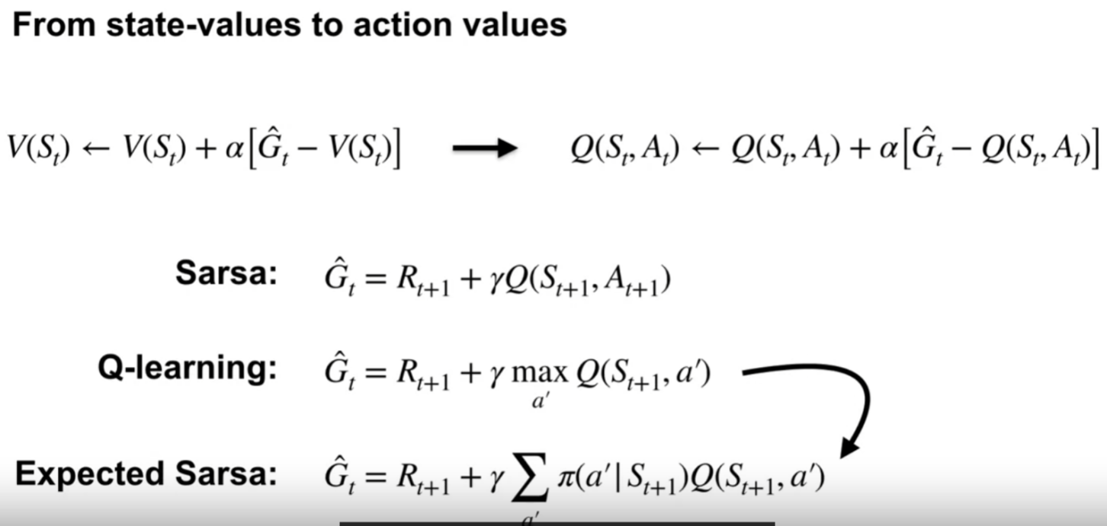

Planing with model

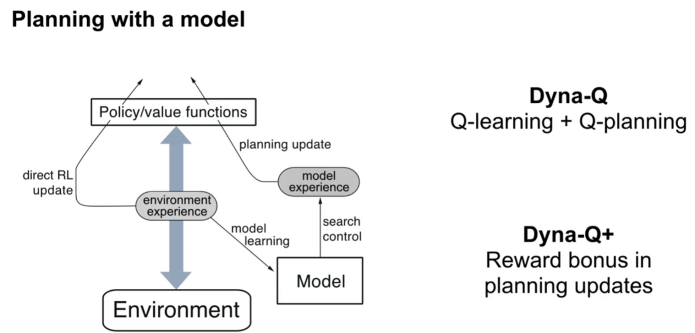

**ON-POLICY PREDICTION WITH APPROXIMATION**

* TD and Monte Carlo with State Aggregation: speed up experiment much more compare to tabular representation

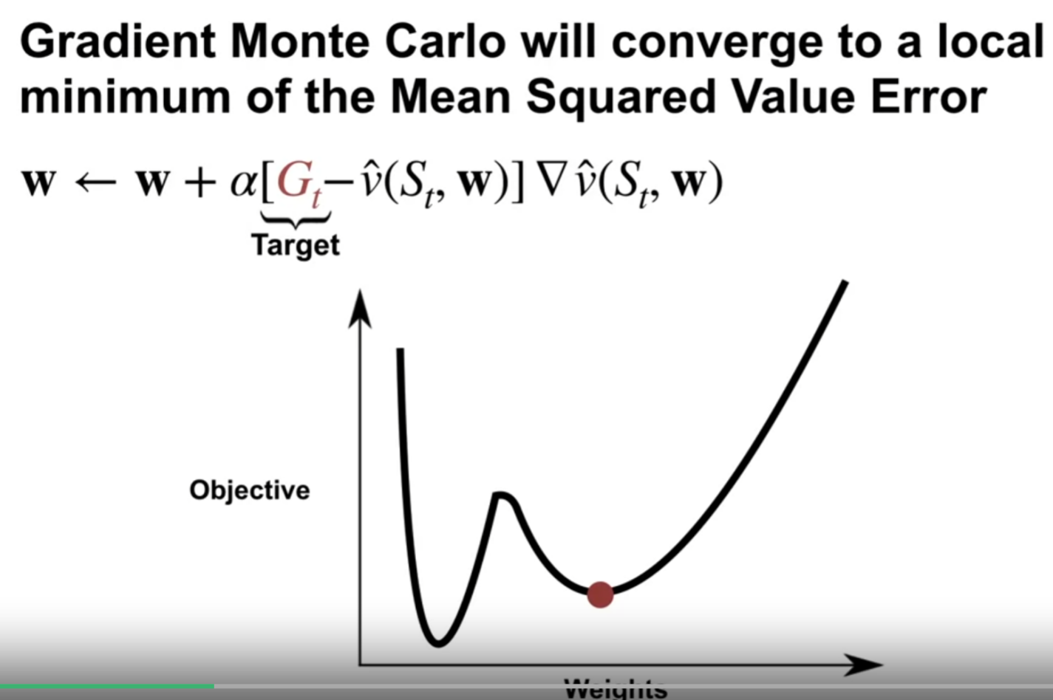

Td depends on the estimate value of next state, thus it’s biased

